Macintosh HD:Users:ccorbett:Desktop:STS Vector Logo-Final.eps

BLACKBOARD FOR STUDENTS:

FACT SHEETS

(For more information, contact Student Technology Services at 314.935-7100 or visit sts.wustl.edu)

HOW TO ACCESS READINGS IN YOUR COURSE

1. **Log into Blackboard** [**https://bb.wustl.edu**](https://bb.wustl.edu)**, using your WUSTL Key**

**and WUSTL Key Password (Chrome or Firefox web browsers are recommended) and access your course.**

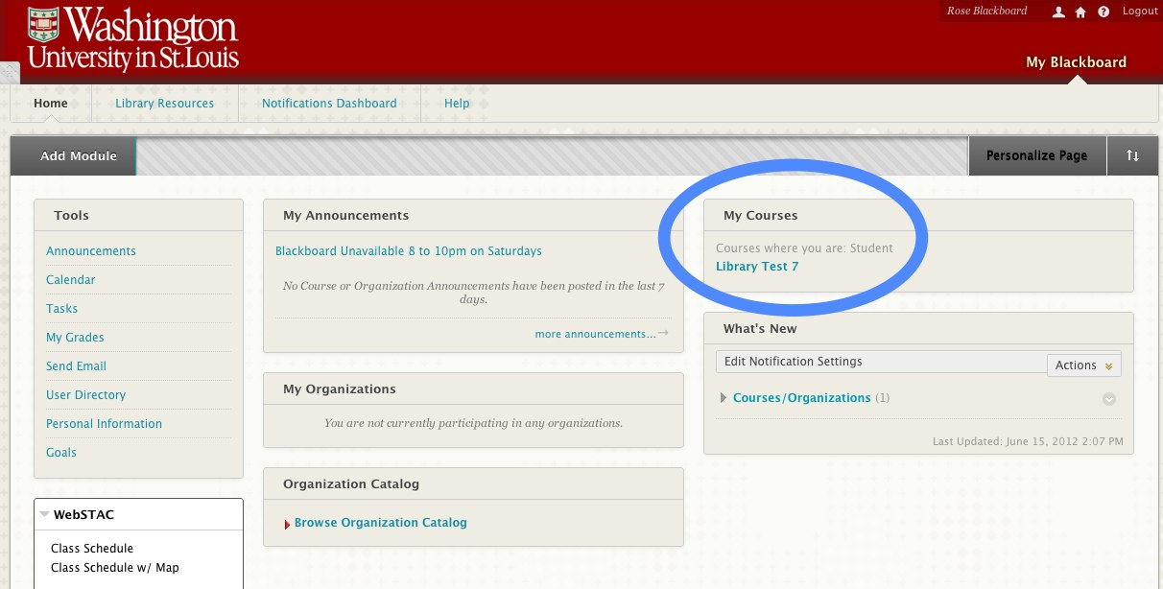

1. **On the menu in the left hand column, click on “Content.”**

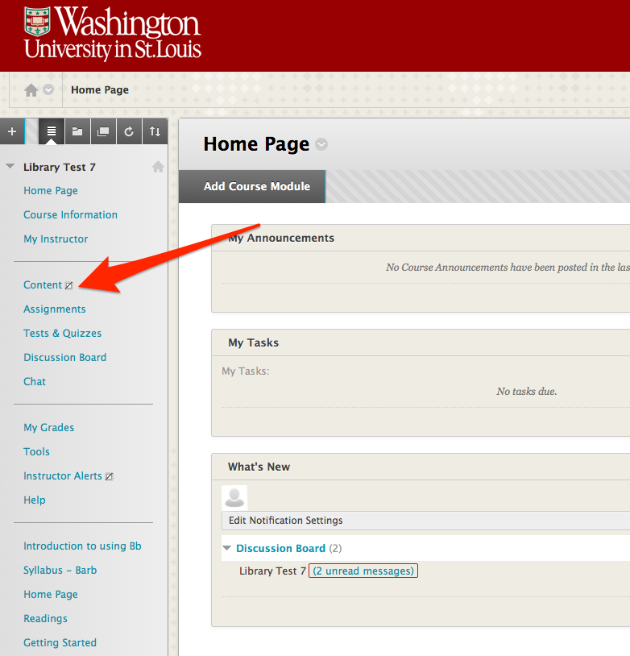

1. **Readings should be listed as a choice. (Readings may also be found in its own separate category of the menu.)**

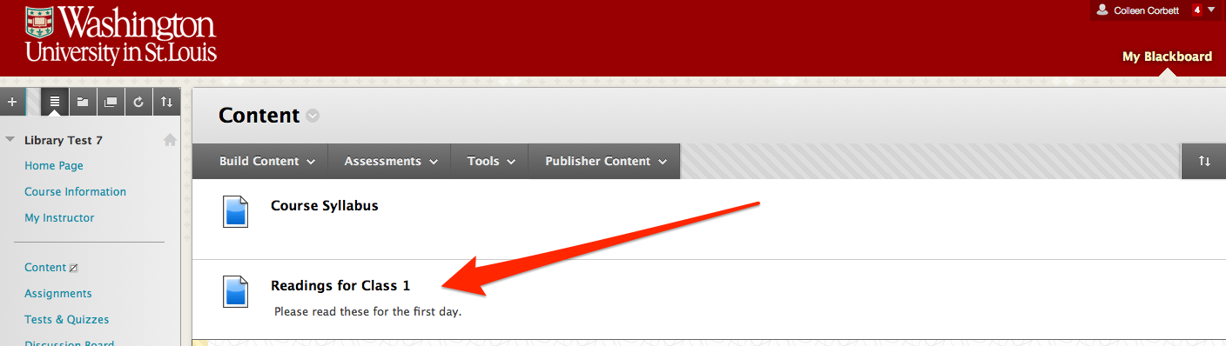

Macintosh HD:Users:ccorbett:Desktop:logo.pdf